INTRODUCTION TO THE LIGHT MICROSCOPE
--Internet Lab--
Introduction: If you missed the microscope lab we did in class, you will need to make it up by using a "virtual microscope" which can be accessed on the internet. The virtual microscope is a little more complicated than the microscope we used in the lab, but it will not be difficult to use.
Access the Virtual Microscope at http://www.udel.edu/biology/ketcham/microscope/

Click on the link that says "the virtual scope"
1. Familiarize yourself with the microscope, run the tutorial and examine the parts you will be working with.
a. How many objectives are on the virtual microscope?
b.What are the numbers listed on each of the objectives?
c. What is the total magnification on each objective lens?

2. You will be looking at the slide (top right) labeled "letter e". Follow the tutorial and use the microscope adjustments to focus the "e" on each of the objectives.
Draw the "e" exactly as it appears
Scanning (4) | Low (10) | High (100)
3. Which letter on the microscope points to the
OCULAR ________
COARSE ADJUSTMENT ______
FINE ADJUSTMENT ______
STAGE CENTERING ______
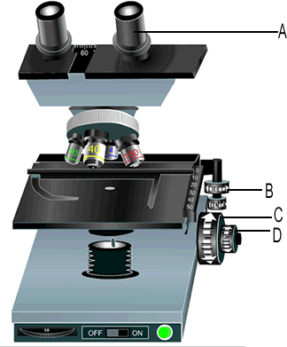
5. Go to www.biologycorner.com/microscope/. Now view sev
eral microscope images of "common things".
After viewing the images, go to the quiz. Write down the names of the specimens for each letter.
A. _____________________________
B. _____________________________
C. _____________________________
D. _____________________________
E. _____________________________
F. _____________________________
G. _____________________________
H. _____________________________

