PHYLUM PLATYHELMINTHES
-FREE LIVING FLATWORMS
-DO NOT LIKE LIGHT

PLANARIA -COMMON FLATWORM
http://www.youtube.com/watch?v=A6N8KZqGAJg anatomy
http://www.youtube.com/watch?v=Ich4Y_K6GuM feeding
http://www.youtube.com/watch?v=CVJwrUPmWxE

- HERMAPHRODITES

-CAN REGENERATE
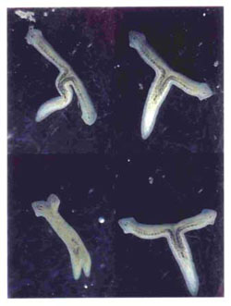

-MOST ARE PARASITES

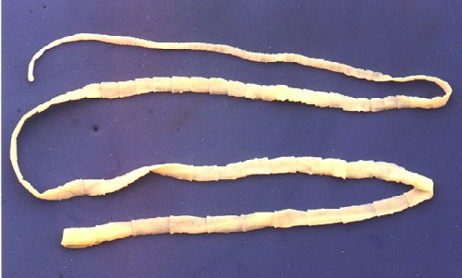
- ACOELOMATES- NO BODY CAVITY
-BILATERAL SYMMETRY
-MOUTH- ONLY OPENING
SCOLEX- MOUTH 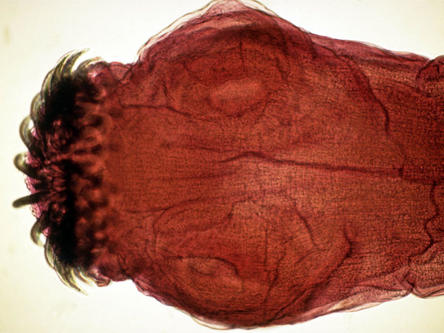

PHYLUM NEMATODA- ROUND WORMS

-PSEUDOCOELOMATES
- HAVE 1 WAY GUT- MOUTH AND ANUS
-DIGESTIVE TUBE MORE SPECIALIZED
1. FRONT- INGESTS FOOD
2. MIDDLE- BREAKS FOOD DOWN
ABSORBS NUTRIENTS
3. BACK- EXPELS WASTE

NEMATODE DISEASES

1.DOG INTESTINAL WORMS ASCARIS
2. CROP DISEASES
3. LIVESTOCK DISEASES

DISEASE IS THE REASON HUMAN FECES IS NOT USED AS FERTILIZER

TAPEWORMS- ARE PARASITES
-1500 SPECIES, 7 HUMAN SPECIES
-SCOLEX- TAPEWORM HEAD- TEETH ATTACH TO INTESTINES

PHYLUM ANNELIDA: SEGMENTED WORMS
http://www.youtube.com/watch?v=hNwht0-TgzE&feature=related annelid song
http://www.youtube.com/watch?v=DZig6EL5B6A large earthworm

1. BODIES HAVE INTERNAL WALLS CALLED SEPTA THAT SEPARATE SEGMENTS.

2. FIRST FEW SEGMENTS CARRY EYE STRUCTURES AND MAY HAVE ANTENNAE

3. LONG TUBE GUT RUNS LENGTH OF BODY

4. MANY HAVE CROP AND GIZZARD FOR STORING AND GRINDING FOOD, SOME HAVE CHEWING MOUTH PARTS.

5. AQUATIC ANNELIDS HAVE GILLS, TERRESTRIAL BREATH THROUGH DIFFUSION THROUGH THE SKIN.

6. CLOSED CIRC. SYSTEM
DORSAL AND VENTRAL VESSELS
AORTIC ARCHES (HEARTS)
7. HAVE PAIRED NEPHRIDIA / SEGMENT AND liquids (ammonia) WASTE REMOVAL

8. WELL DEVELOPED NERVOUS SYSTEM

9. BRAIN AT FRONT END OF BODY- VENTRAL NERVE CHORD RUNS LENGTH OF BODY

10. SENSORY BEST IN FREE LIVING, MARINE WORMS

STATOCYSTS, CHEMICAL RECEPTORS,
1OR MORE PAIRS OF EYES, SENSORY
TENTACLES

MOVEMENT- LONGTITUDINAL AND CIRCULAR MUSCLES
USE SETAE - BRUSHLIKE FEET ON EACH SEGMENT OF BODY

REPRODUCTION-
SOME ASEXUAL- BUDDING

SEXUAL- SEPARATE SEXES,

SOME HAVE EXTERNAL FERTILIZATION - OPEN WATER RELEASE OF EGG AND SPERM

EARTH WORMS AND LEECHES

1. HERMAPHRODITES- INTERNAL FERTILIZATION

2. EARTHWORMS PAIR UP AND ATTACH AT CLITELLUM TO EXCHANGE SPERM- SPERM IS STORED UNTIL USED, EGGS RELEASED IN MUCUS COVERED CONTAINER THAT FORMS AROUND CLITELLUM AND SLIPS OFF.
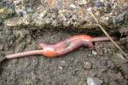
OLIGOCHAETES- CLASS NAME
EARTHWORMS, TUBIFLEX WORMS- RED, THREADLIKE WORMS USED FOR FISH FOOD

CLASS POLYCHAETES-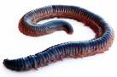 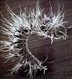
MARINE WORMS- PAIRED APPENDAGES WITH SETAE ON THE ENDS.

http://www.youtube.com/watch?v=vpv9P1KOVMQ

LEECHES- CLASS HIRUDINAE

1. SOME SCAVENGERS, SOME ARE PREDATORS (BLOOD SUCKERS)

2. GENERALLY ABOUT 6 CM OR SHORTER.

3. MOSTLY FRESHWATER PARASITES

4. 1/4 LEECHES ARE CARNIVORES

5. USE SUCKERS TO ANCHOR AND FEED.

6. USE THEIR PROBOSCIS TO PENETRATE AND FEED. SOME USE RAZOR SHARP JAWS TO CUT INTO PREY.

7. LEECH SWALLOWS 10 TIMES IT’S WEIGHT IN BLOOD WHILE FEEDING

8. CAN TAKE 200 DAYS TO DIGEST.

