Human Blood Types

Co Dominant trait- Alleles share control of a characteristic
3 blood type alleles
I^{A} = A
I^{B =} B
I = O
Since there are three different alleles, there are a total of six different genotypes at the human ABO genetic locus (LOCATION OF A GENE ON A CHROMOSOME).
Allele from  Parent 1 | Allele from  Parent 2 | Genotype of  offspring | Blood types of  offspring
A | A | AA | A
A | B | AB* | AB
A | O | AO | A
B | A | AB* | AB
B | B | BB | B
B | O | BO | B
O | O | OO | O

AB parent - can give A or B
O parent- recessive- neither A nor B
A parent- only A, not B
Different blood types are caused by the presence of a protein cell-surface marker*. An antigen on the surface of the red blood cells' plasma membrane.
When mixed with the wrong blood type, these antigens are bound by antibodies which, causes the cells to clump.
There are four basic Blood types:
- Type A with A antigens on the red cells and anti B antibodies in the plasma.
- Type B with B antigens on the red cells and anti A antibodies in the plasma.
- Type AB with both A and B antigens on the red cells and no blood type antibodies in the plasma.
- Type O with no antigens on the red cells and both anti A and anti B antibodies in the plasma
Blood Transfusion Information
AB- universal recipient- takes all blood types A- can receive A or O
O- can receive only O type B- can receive B or O
O- universal donor

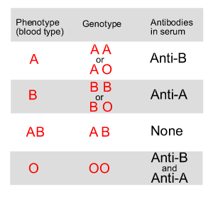
45% of the population are type O,
42% type A
10% type B
3% type AB.

Most people also have another inherited protein of the red blood cells known as the Rh factor, or antigen D. When the D antigen is present, a person's blood type is designated Rh positive. When antigen D is missing, the blood type is classified Rh negative
If a type AO woman is crossed with a type AB male, determine the possible blood type outcomes of the child.

