How to Use the Microscope

Types of Microscopes
Light Microscope - the models found in most schools, use compound lenses to magnify objects. The lenses bend or refract light to make the object beneath them appear closer. Common magnifications: 40x, 100x, 400x
Stereoscope - this microscope allows for binocular (two eyes) viewing of larger specimens.
Scanning Electron Microscope - allow scientists to view a universe too small to be seen with a light microscope. SEMs do not use light waves; they use electrons (negatively charged electrical particles) to magnify objects up to two million times.
Transmission Electron Microscope - also uses electrons, but instead of scanning the surface (as with SEM's) electrons are passed through very thin specimens.

Parts of the Microscope

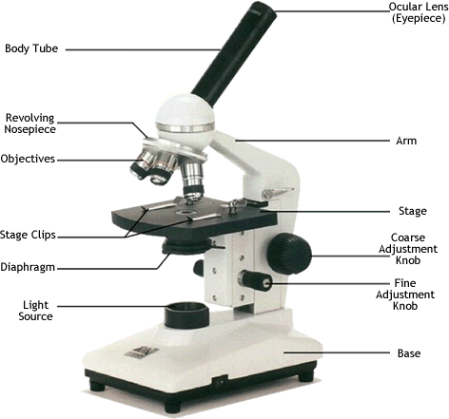

Magnification
Your microscope has 3 magnifications: Scanning, Low and High. Each objective will have written the magnification. In addition to this, the ocular lens (eyepiece) has a magnification. The total magnification is the ocular x objective
 | Magnification | Ocular lens | Total Magnification
Scanning | 4x | 10x | 40x
Low Power | 10x | 10x | 100x
High Power | 40x | 10x | 400x

General Procedures
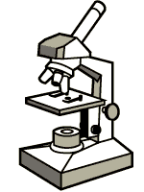
1. Make sure all backpacks and junk are out of the aisles.
2. Plug your microscope in to the extension cords. Each row of desks uses the same cord.
3. Store with cord wrapped around microscope and the scanning objective clicked into place.
4. Carry by the base and arm with both hands.

Focusing Specimens
1. Always start with the scanning objective. Odds are, you will be able to see something on this setting. Use the Coarse Knob to focus, image may be small at this magnification, but you won't be able to find it on the higher powers without this first step. Do not use stage clips, try moving the slide around until you find something.
2. Once you've focused on Scanning, switch to Low Power. Use the Coarse Knob to refocus. Again, if you haven't focused on this level, you will not be able to move to the next level.
3. Now switch to High Power. (If you have a thick slide, or a slide without a cover, do NOT use the high power objective). At this point, ONLY use the Fine Adjustment Knob to focus specimens.
4. If the specimen is too light or too dark, try adjusting the diaphragm.
5. If you see a line in your viewing field, try twisting the eyepiece, the line should move. That's because its a pointer, and is useful for pointing out things to your lab partner or teacher.

Drawing Specimens
1. Use pencil - you can erase and shade areas
2. All drawings should include clear and proper labels (and be large enough to view details). Drawings should be labeled with the specimen name and magnification.
3. Labels should be written on the outside of the circle. The circle indicates the viewing field as seen through the eyepiece, specimens should be drawn to scale - ie..if your specimen takes up the whole viewing field, make sure your drawing reflects that.
Example:
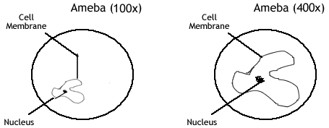

Making a Wet Mount
1. Gather a thin slice/peice of whatever your specimen is. If your specimen is too thick, then the coverslip will wobble on top of the sample like a see-saw, and you will not be able to view it under High Power.
2. Place ONE drop of water directly over the specimen. If you put too much water, then the coverslip will float on top of the water, making it hard to draw the specimen, because they might actually float away. (Plus too much water is messy)
3. Place the coverslip at a 45 degree angle (approximately) with one edge touching the water drop and then gently let go. Performed correctly the coverslip will perfectly fall over the specimen.

