CHAPTER 24- ARTHROPODS

PHYLUM ARTHROPODA- (JOINTED LEG)
SPIDERS, INSECTS, CRAYFISH

4 SUB-PHYLUMS
1. TRILOBITA- EXTINCT- TRILOBITES
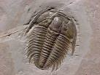
2. CRUSTACEA
CLASS DECAPODA- CRAYFISH, LOBSTER, CRABS
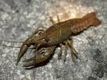

3. CHELICERAE
CLASS ARACHNIDA- SPIDERS, SCORPIONS, TICKS, MITES, HORSESHOE CRABS
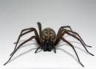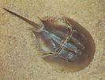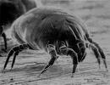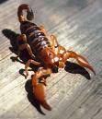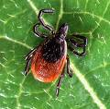
4. HEXAPODA
CLASS: INSECTA- INSECTS
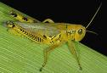

5. MYRIAPODA- CENTIPEDES AND MILLIPEDES
CLASS- CHILIPODA-CENTIPEDES
CLASS- DIPLOPODA- MILLIPEDES

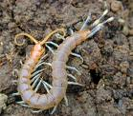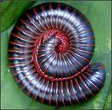

Class Arachnida: SPIDERS, SCORPIONS, TICKS/MITES, HORSESHOE CRABS

Characteristics:
1. Mostly carnivores
2. Most have poison glands with fangs (chelicerae)
3. 1 pair of pedipalps- mouth parts- aid in chewing
4. Have cephalothorax and abdomen
5. 4 pairs of legs attached to cephalothorax

Comparison of spiders and scorpions

FEATURE SPIDER SCORPION
FOOD CARNIVORE CARNIVORE
HABITAT EVERYWHERE TROPIC/SUBTROPIC
DEFENSE FANGS STINGER
MOUTH PARTS CHELICERAE ENLARGED PEDIPALPS

TICKS AND MITES

1. FUSED CEPHALOTHORAX / ABDOMEN
2. MOST ABUNDANT
3. TRANSMIT DISEASES- ARE PESTS

ARACHNID RESPIRATION

1. AIR ENTERS SPIRACLES IN ABDOMEN

2. AIR TRAVELS TO BOOK LUNGSFOR GAS EXCHANGE

3. AIR CARRIED TO TISSUES THROUGH TRACHEA

ARACHNID EXCRETORY PROCESS

1. MALPHIGIAN TUBULES COLLECT BODY FLUIDS AND REMOVE WASTE, THEN CARRY WASTE TO INTESTINE

2. WATER IS REMOVED FROM THE WASTE- SOLID WASTE REMOVED

SOME SPIDERS HAVE COXAL GLANDS AT BASE OF LEG WHICH ALSO ARE USED FOR WASTE REMOVAL

SUB PHYLUM CRUSTACEA: LOBSTER, CRAYFISH, CRABS

CRAYFISH CHARACTERISTICS:

1. EXOSKELETON (CARAPACE) MADE OF CALCIUM CARBONATE
2. CEPHALOTHORAX- COVERED BY A CARAPACE
3. 7 SEGMENT ABDOMEN
4. MUSCLES ATTACHED TO INSIDE OF EXOSKELETON SO ANIMAL HAS LEVER-LIKE APPENDAGE MOVEMENTS
MOLTING PROCESS:

1. ENZYMES DISSOLVE INNER LAYER OF CARAPACE

2. OLD EXOSKELETON SOFTENS AND BREAKS AT SEAMS

3. OLD EXOSKELETON IS SHED

4. NEW EXOSKELETON FORMS

SUB PHYLUM HEXAPODA- INSECTS

1. EXOSKELETON
2. 3 BODY SEGMENTS – HEAD, THORAX, ABDOMEN
3. 1 OR 2 PAIRS ANTENNAE
4. COMPOUND EYES- MULTIPLE LENSES
5. SOME WINGED, SOME NOT
6. 3 PAIRS OF LEGS ATTACHED TO THORAX
7. ORGANS IN ABDOMEN
8. MOUTHPARTS – MANDIBLES- CHEWING ACTION
SUBPHYLUM MYRIAPODA- CENTIPEDES AND MILLIPEDES
1. CENTIPEDES-
1 PAIR LEGS/SEGMENT
CARNIVORES
POISON CLAWS FOR FEEDING

2. MILLIPEDES-
2 PAIRS LEGS/SEGMENT HERBIVORES

